INSTALLATION GUIDE

Prerequisites for Installing Licencia Statistix Application
- Internet Information Services (IIS)
- Dot Net Frame Work 3.5
- Microsoft SQL Server Express 2008

After prerequisites installation
Register .Net Framework in IIS. To do this, open command window by running cmd command.
Go to path “C:\WINDOWS\Microsoft.NET\Framework\v2.0.50727”.
Type and run command aspnet_regiis –i.

Note: For windows-Vista and Windows-7, refer below section: Settings for Windows Vista and Windows 7

Settings for Windows Vista and Windows 7
Before application can be installed a web hosting environment (IIS6 or IIS7) needs setup. By default, IIS will not be installed. To install IIS, go to Control Panel –> Programs –> Turn Windows features on and off.

1. Check: Internet Information Services

2. Expand: Internet Information Services

3. Expand: Web Management Tools

4. Expand: IIS 6 Management Compatibility

5. Check: IIS Metabase and IIS 6 configuration compatibility.

6. Expand: World Wide Web Services

7. Expand: Application Development Features

8. Check: ASP.NET

9. Expand: Common HTTP Features

10. Check: Static Content

11. Expand: Security

12. Check: Windows Authentication

Please refer following image for more details.

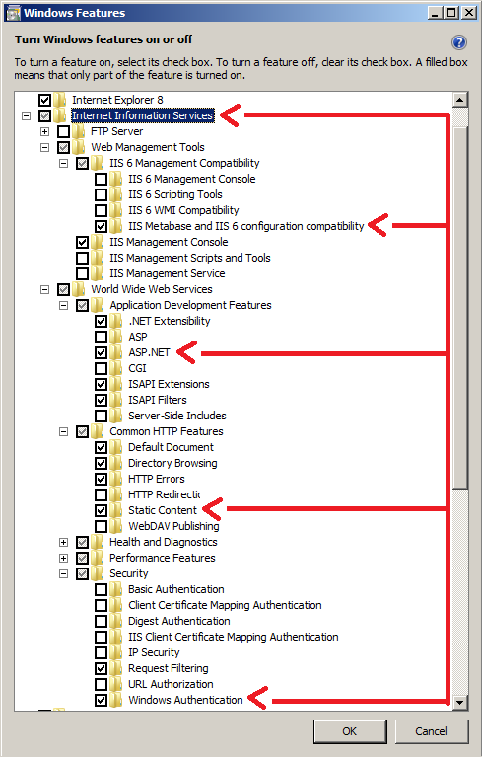

Installation Steps
Double click the “setup.exe” file to start the Installation.
The first page is the Welcome page of the Wizard, click “Next” to continue.

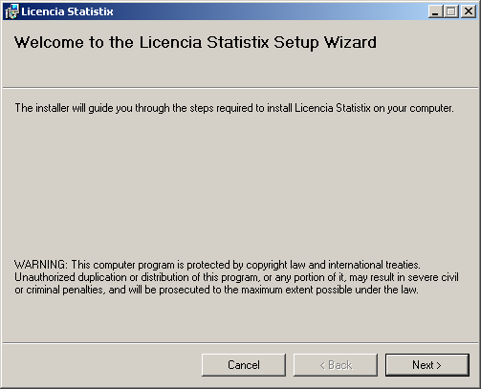

In the second page, you provide the Company name, and the time interval to import from the master CallStatistics table in minutes, (Default is 30) and click “Next”.

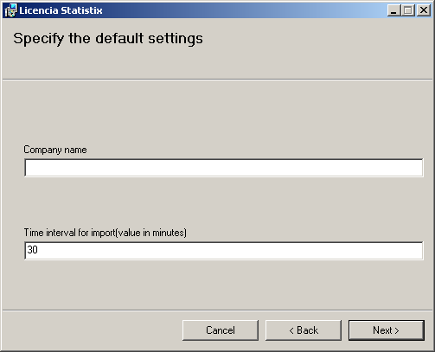
Here you have to provide the master database details, from which the CallStatistics table will be imported to the Licencia Statistix database and Click “Next”.

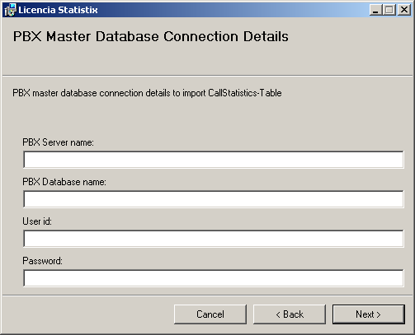
Here you will specify old or new Licencia Statistix database to use.

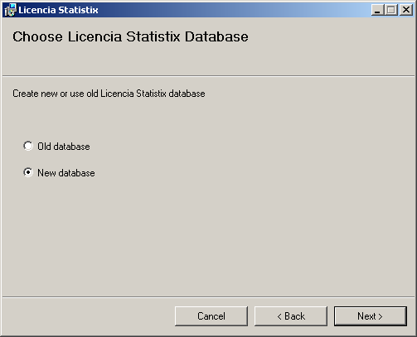
In this page, you provide the server credentials and the database name to be created for the Licencia Statistix application and click “Next”.

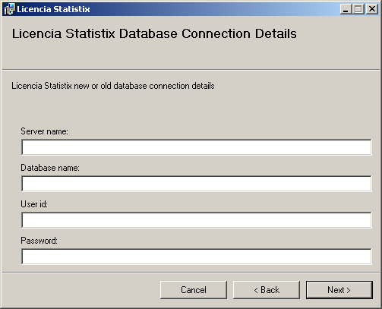

In the next page select the installation address and click “Next”.

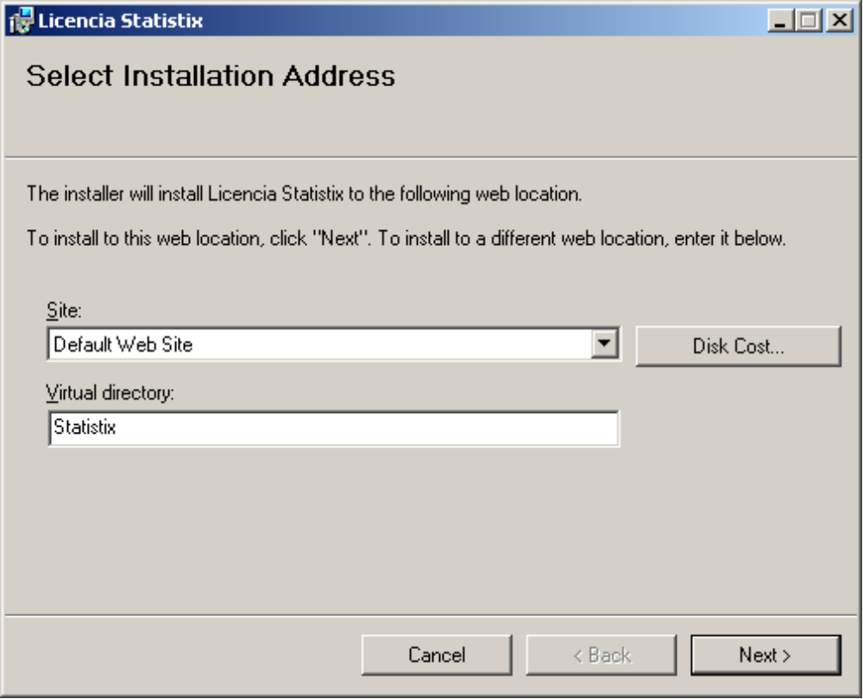

Here you confirm all your inputs and click “Next” to install the application to the computer.

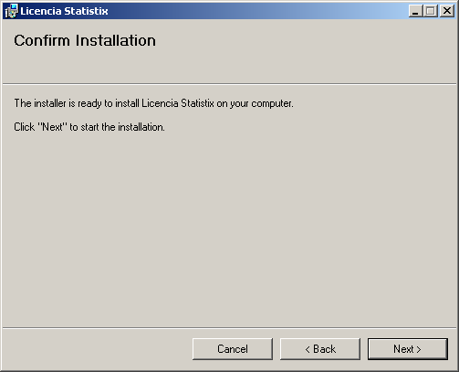

You will get the Progress bar as in the picture.

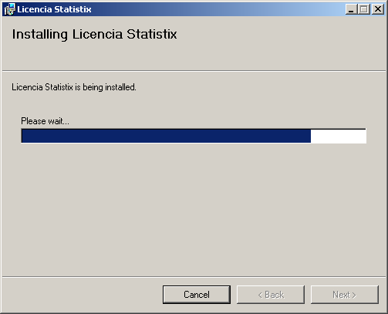
Wait until the application finishes installation and you get the following page.

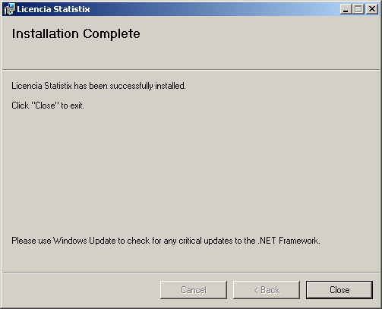

Click “Close” to exit the Setup.

Settings for Import and Export (For IIS 7)
IIS 7 Settings for importing/exporting Area-Code, Area-Description and Area-RangeTypes. If IIS version is 7.0 then please configure the Application Pool as described below. Otherwise while importing you will get error: 'Microsoft.Jet.OLEDB.4.0' provider is not registered

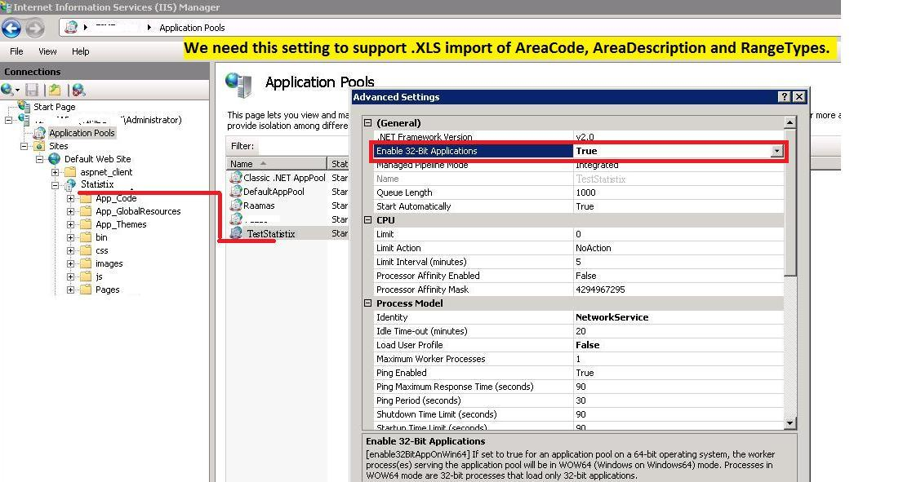

Remove Read-only attribute for “ExcelFiles” folder
Do the same thing for “Reports” folder.
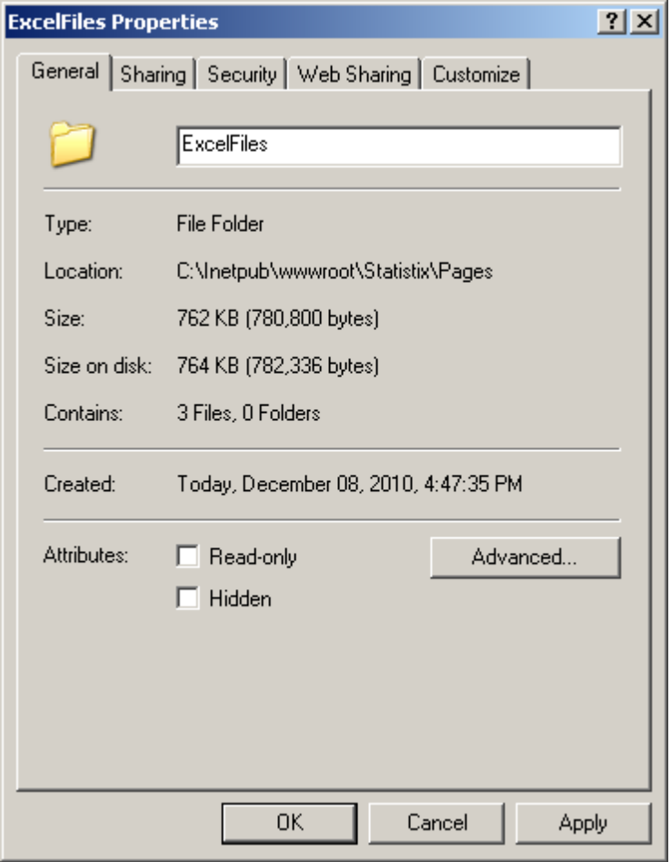

Give Write permission to “ExcelFiles” folder
Do the same thing for “Reports” folder.

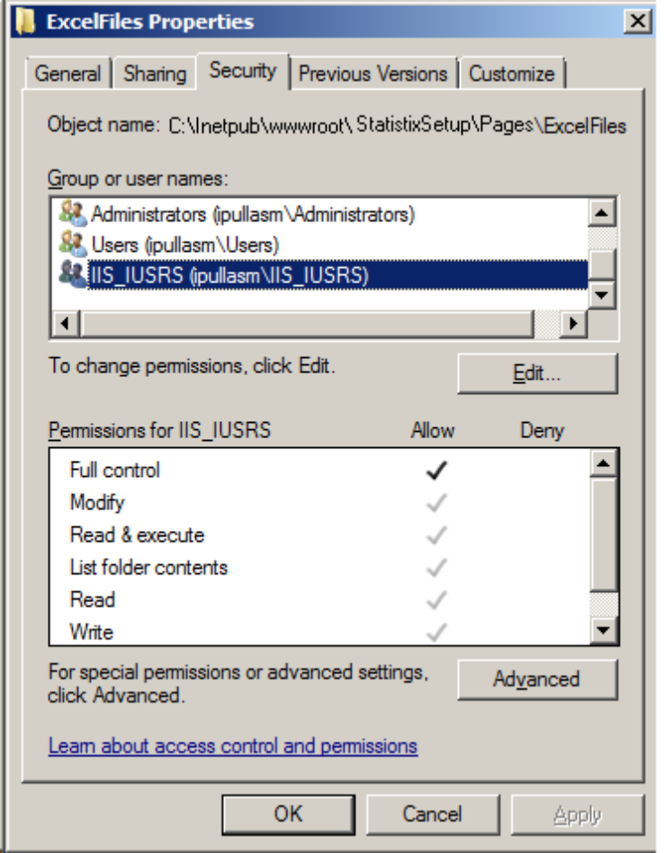

IIS settings for authentication (For IIS 6)

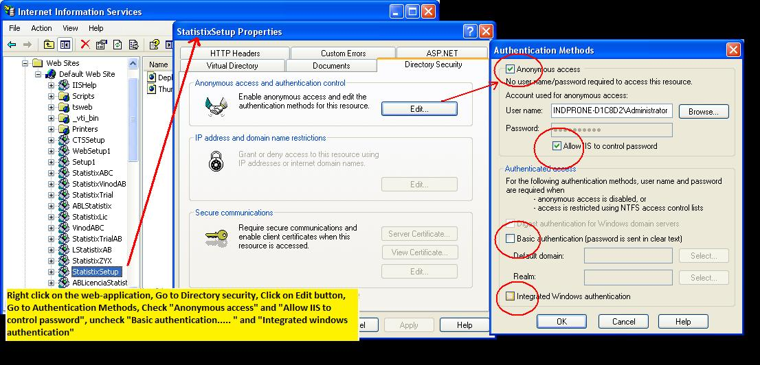

Setting up “Printer name” and “Email address” for automatic recurrance reports
Go to: “Control Panel\Hardware and Sound\Devices and Printers”
Note down Printer name for automatic recurrance reports and set it up in Settings page as shown below
Note: Printer name should be taken from the server.
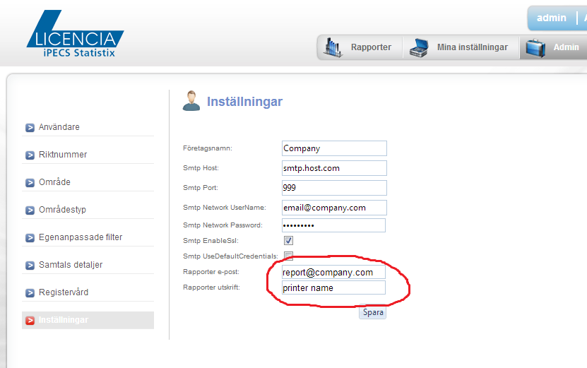

Admin credentials for the Licencia Statistix Web application
Username: admin
Password: admin

